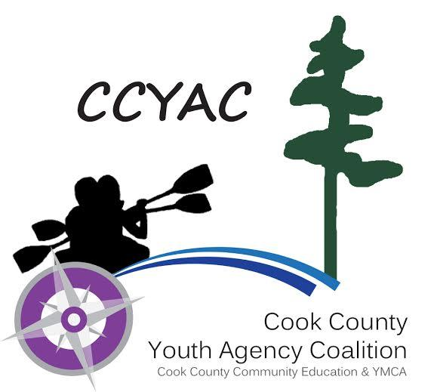

Individual Child Care Program Plan (ICCPP) for Allergies
Must be accompanied by a Medication Administration Form

Child Information:
Child’s Name (First, Last, Middle): _______________________________________________________________________________ Birthdate:_________________
Allergy To:___________________________________________________________________________________________________________________________________________
Is the child Asthmatic? No Yes (If Yes = Higher Risk for Severe Reaction)
Allergy Symptoms:
Describe the symptoms your child experiences when a food allergen has been ingested or when the child is exposed to an allergy trigger.
____________________________________________________________________________________________________________________________________________________________________________________________________________________________________________________________________________________________________________________________________________________________________________________________________________________________________________________________

Treatment:
Describe the treatment/medication administration (type, dosage, etc) when your child is exposed to an allergen.
____________________________________________________________________________________________________________________________________________________________________________________________________________________________________________________________________________________________________________________________________________________________________________________________________________________________________________________________

Asthmatic Symptoms:
Describe the causes of asthmatic issues and asthmatic symptoms your child experiences
____________________________________________________________________________________________________________________________________________________________________________________________________________________________________________________________________________________________________________________________________________________________________________________________________________________________________________________________

Treatment:
Describe the treatment/medication administration (type, dosage, etc) when your child is having an asthmatic episode:
____________________________________________________________________________________________________________________________________________________________________________________________________________________________________________________________________________________________________________________________________________________________________________________________________________________________________________________________

Emergency Contact Information
Call 911 whenever Epinephrine has been administered. Call the parent. State that an allergic reaction has been treated and additional epinephrine may be needed. Stay with the child.

Parent Information:
Parent/Guardian Name (#1): _________________________________________________________________________________________________________________
Home Phone:__________________________________WorkPhone:______________________________________ Cell Phone: _________________________________
Parent/Guardian Name (#2): _________________________________________________________________________________________________________________
Home Phone:__________________________________WorkPhone:______________________________________ Cell Phone:_________________________________
Health Care Information
Primary Health Provider’s Name: ________________________________________________ Phone: _____________________________________________________
Name of Clinic: ________________________________________________________________________Phone: ____________________________________________________
Name/Title of other Specialist (if applicable): __________________________________________________________Phone: ____________________________
Name of Specialist’s Clinic: _________________________________________________________________________________Phone: ____________________________
Authorization is hereby given to the child care provider to obtain emergency medical care or treatment in the event of an emergency. ☐Yes or☐ No
If physician above is unavailable, I authorize another licensed physician to treat my child ☐Yes or☐ No
Specific Allergy Action Plan by Center Staff
Train staff on each child’s specific allergy and response plan
Staff preparing food will check food labels and be knowledgeable about food allergies
Post allergies near areas where food is served, prepared, and transported.
Bring a list of allergies and medications along on off-site trips
Reduce exposure to allergens by not sharing food
Ensure proper hand washing procedures are followed
Observe and monitor child for any signs of allergic reactions
Ensure that medication is immediately available to administer in case of an allergic reaction (in the classroom, playground, field trips, etc)
Ensure that a person trained in Medication Administration accompanies the child on any off-site activities

The Parent/Guardian will:
Ensure the child care facility has a sufficient supply of emergency medication
Replace medication prior to the expiration date
Alert the staff of any changes (such as a new allergy has been discovered) by filling out a new ICCPP form

Parent/Guardian Signature:
Parent/Guardian Signature Printed Name Date

__________________________________________________________________________________________
Provider Signature Printed Name Date

