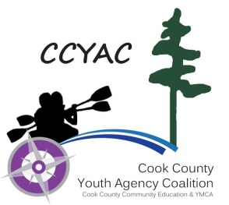

Cook County Child Care Center Permission Form:
Bug Spray, Sun Screen, and Diaper Cream
Child’s First and Last Name:______________________________________________________________________________
I give permission for the Cook County Child Care Center Staff to apply the following over the counter skin products to my child:

Type of Over the Counter Skin Product | Brand
Bug Spray
Sun Screen
(Spray-on sunscreen is preferred)
Diaper Cream

All over the counter skin products must:
- Be in the original container and labeled with a non-toxic permanent marker with the child’s first and last name.
- Be used according to the manufacturer’s instructions and recommendations for application.
- Not be used beyond the expiration date of the product
- Have at least a sun protection factor of 15 or higher for sun screen
- Be inaccessible to children

Parent Signature _________________________________________________ Date: _________

Parent Name (print) ________________________________________________________________

Provider Signature _______________________________________________ Date: __________

Provider Name (print)________________________________________________________________

